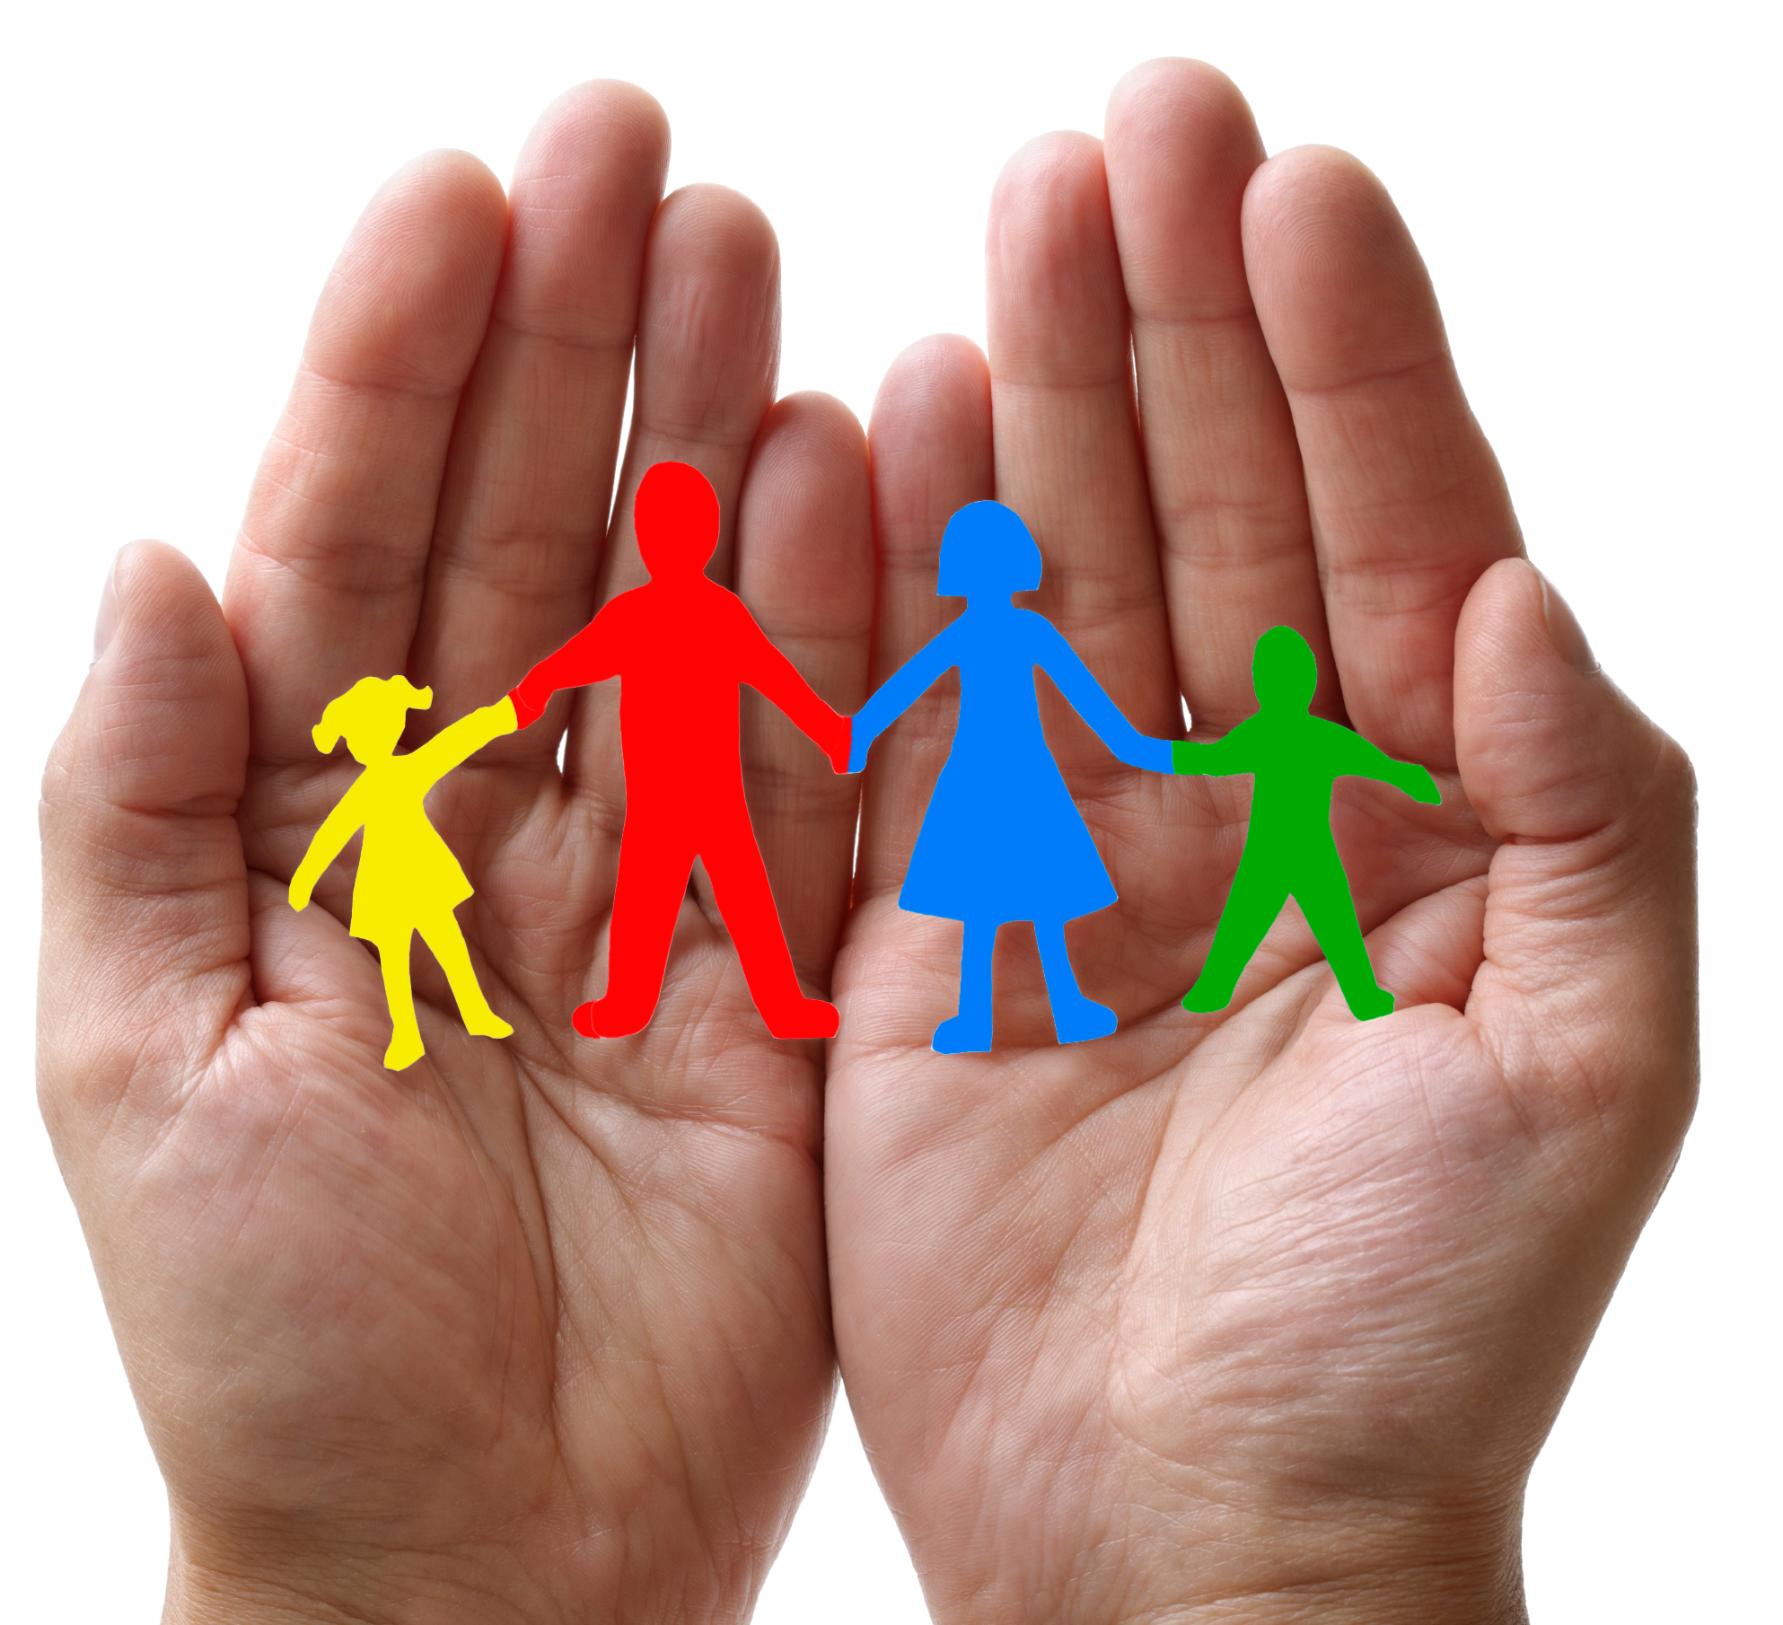
Family-to-Family Communities (F2FC)
Connecting Families of Individuals with Deaf-Blindness via Distance Technology

F2FC brings families together to connect, share information and resources, and offer support to one another in the journey of supporting their family member with deaf-blindness.

“I love knowing that there are others like me! It’s wonderful not to feel so isolated.” (parent)
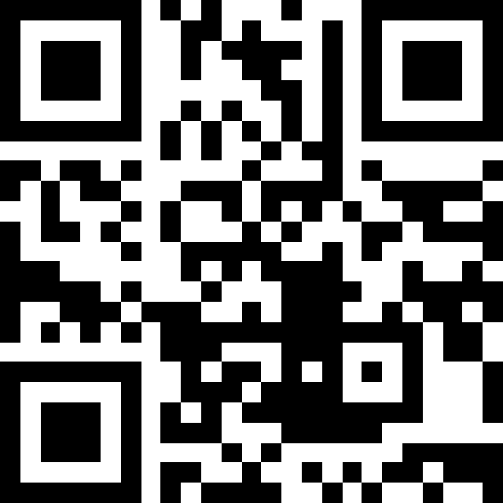
F2FC registration is open until
September 1, 2023

Questions?
contact cdarrah@uga.edu
or your state deaf-blind project

Facebook
https://tinyurl.com/F2FCFacebook
Registration
https://tinyurl.com/F2FC2023

Each F2FC is comprised of 8-10 family members; is guided by trained Facilitators; meets once per month for 90 minutes via video-conference or phone; topics are chosen by the group and include structured conversation and open sharing. Your regular participation is vital to the group!

Facilitators will contact participants in August; monthly meetings will be Sept 2023 – May 2024
2023-2024 Family-to-Family Communities (adjust for time zones) descriptions include sample topics
- Love, Laughter, & Mindfulness: 1st Thursday/month at 8:30pm ET; boundaries, self-care, and ways to thrive in life while also caring for your children with deaf-blindness; Facilitators- Heather Joy Magdelano & Donia Shirley
- Families with Members who have Peroxisomal Disorders: 3rd Monday/month at 8:30pm ET; Communication, educational support, & life balance; Facilitators- Krista Olsen & Katie Sacra
- Families with Members who have CHARGE: 1st Monday/month at 8pm ET; unique needs and services, building a network of support, family dynamics, planning for the future; Facilitators- Jenn Henkle & Katrina Michel
- Families with Members who have Usher syndrome: 3rd Wednesday/month at 8pm ET; support for BOTH moms and dads facilitated by a married couple, connections, and sharing resources; Facilitators- Morgan & Amanda Campbell
- Adult Life (age 22+): Last Wednesday/month at 7pm ET; for family members of adults who are deafblind; adult life systems, resources and supports; Facilitators- Patti McGowan & Sheri Stanger
- Families with Children who have Complex Needs: 2nd Thursday/month at 7pm ET; health care, support providers, educational services, waivers, self-care, balancing family life; Facilitators- Michelle John & Jana Villemez
- Families with School-Age Children: 2nd Wednesday/month at 1pm ET; IEPs, relationships with your education team, navigating transitions, & promoting friendships; Facilitators- Nilam Agrawal, Brandi Hitzelberger, & Lane McKittrick
- 258 “Very Interesting” Chat: 2nd Thursday/month at 8:30pm ET; Deafblind culture, connections, and advocacy; Facilitators- Maureen Behrens, Valerie Nordstrom, & Heather Withrow (meetings in ASL- must be FLUENT)
- Transition to Life beyond High School: 2nd Thursday/month at 8pm ET; for families of youth ages 14-22, planning for life after high school that is meaningful, purposeful, and enjoyable; Facilitators- Theresa Baldry & Faith Young
- Grandparents and Extended Family: 3rd Wednesday/month at 7pm ET; for family members who want to support their loved ones whose child is deafblind; Facilitators- Rhonda Bryce, Chris & Tony DiLeo, & Jana Villemez
- Spanish-speaking Families: 1st Tuesday/month at 12:00pm ET; education, relationships, self-care, and leadership; Facilitators- Josefina Gonzales & Doris Tellado; registration for this group ONLY https://tinyurl.com/F2FC2023SP

