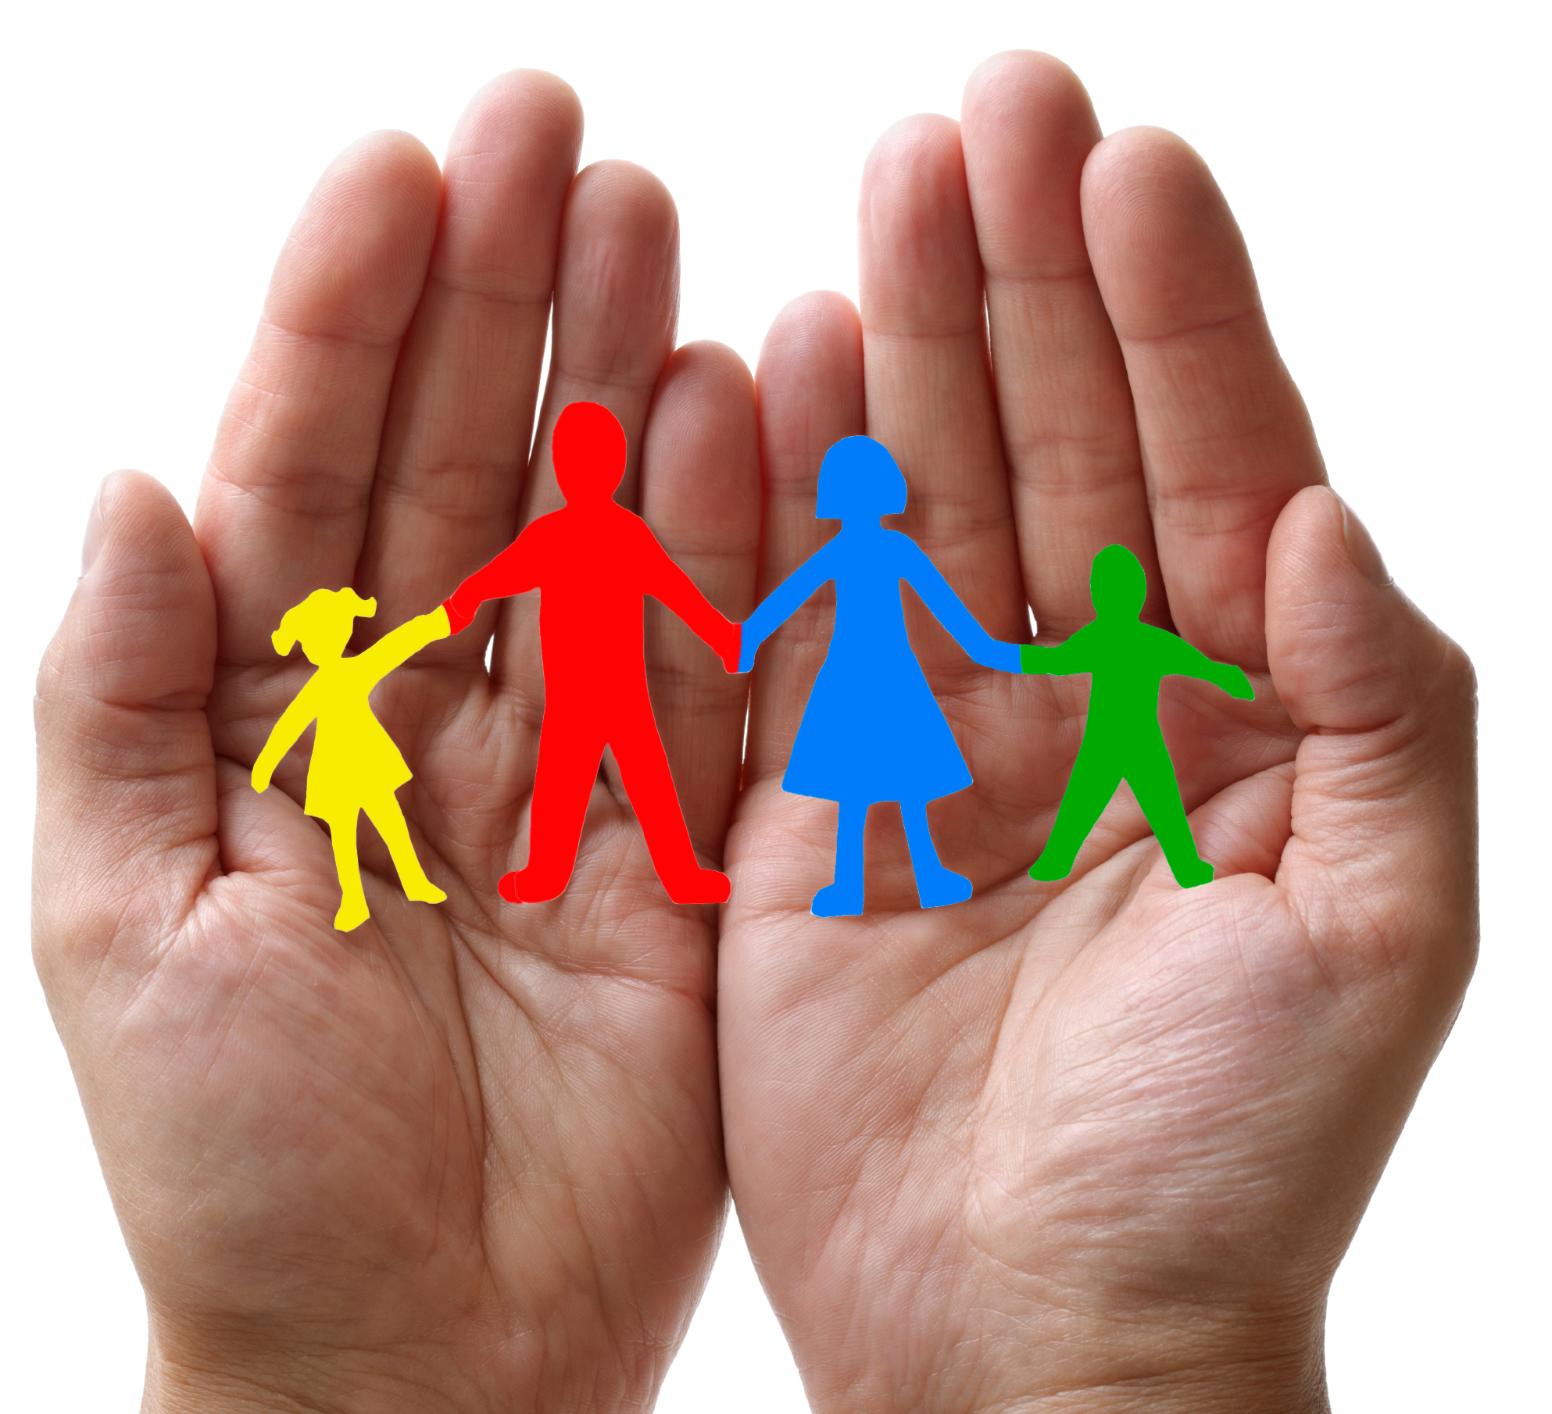
Family-to-Family Communities (F2FC)
Connecting Families of Individuals with Deaf-Blindness via Distance Technology

F2FC brings families together to connect, share information and resources, and offer support to one another in the journey of supporting their family member with deaf-blindness.
“I love knowing that there are others like me! It’s wonderful to not to feel so isolated” (parent)

F2FC Registration is now open until August 31, 2022!
https://tinyurl.com/F2FC2022

contact cdarrah@uga.edu or your state deaf-blind project with questions

https://www.facebook.com/Family-2-Family-Communities-F2FC-100640928924961

Each F2FC is comprised of 8-10 family members; is guided by trained Facilitators; meets once per month for 90 minutes via video-conference or phone; topics are chosen by the group and include structured conversation and open sharing. Your regular participation is vital to the group!

Facilitators will contact participants in August; monthly meetings will be Sept 2022 – May 2023

2022-2023 Family-to-Family Communities (adjust for time zones) descriptions include sample topics
- Love, Laughter, & Mindfulness: 1st Thursday/month at 8:30pm ET; boundaries, self-care, and ways to thrive in life while also caring for your children with deaf-blindness; Facilitators- Heather Joy Magdelano & Donia Shirley
- Families with Members who have Peroxisomal Disorders: 3rd Monday/month at 8:30pm ET; Communication, educational support, & life balance; Facilitators- Jennifer Knox, Krista Olsen, & Katie Sacra
- Families with Members who have Usher syndrome: Dates/times TBD; Peer support, resources, and connections; Facilitators- Pam Aasen & Carly Fredericks registration for this group ONLY https://tinyurl.com/F2FC2022USH
- Families with Members who have CHARGE: 1st Monday/month at 8pm ET; unique needs and services, building a network of support, family dynamics, planning for the future; Facilitators- Jenn Henkle & Katrina Michel
- Adult Life (age 22+): Last Wednesday/month at 7pm ET; for family members of adults who are deaf-blind and also individuals who are deaf-blind; adult life systems and supports; Facilitators- Patti McGowan & Sheri Stanger
- Families with Children who have Complex Needs: 2nd Thursday/month at 8pm ET; health care, support providers, educational services, waivers, balancing family life; Facilitators- Niki Cooper & Jenny Stuhmer
- Families with School-Age Children: 2nd Wednesday/month at 1pm ET; IEPs, relationships with your education team, navigating transitions, promoting friendships, & other hot topics; Facilitators- Brandi Hitzelberger & Lane McKittrick
- Supporting Academic Rigor: 2nd Monday/month at 8pm ET; supporting your student to achieve success in the general curriculum, best practices to attain IEP goals; Facilitator- Nilam Agrawal
- 258 Chat: 2nd Thursday/month at 8:30pm ET; “very interesting” chat, Deaf-Blind culture, connections, advocacy, and communication; Facilitators- Valerie Nordstrom & Heather Withrow (meetings in ASL- must be FLUENT)
- Extended Family Members: 3rd Tuesday/month at 7:30pm ET; for grandparents and other extended family who want to support their loved ones who have a child with deaf-blindness; Facilitators- Rhonda Bryce & Jana Villemez
- Spanish-speaking Families: 1st Tuesday/month at 7:30pm ET; education, relationships, self-care, and leadership; Facilitators- Josefina Gonzales & Doris Tellado; registration for this group ONLY https://tinyurl.com/F2FC2022SP

